JUNE 8, 2024
9:00 AM to 3:15 PM
Menchville Baptist Church
248 Menchville Road
Newport News, VA 23602

This event is open to all 2nd grade Sparky Plaque award achievers.
Exciting fun-filled day of activities, plus:
- T-shirt
- Lunch
- Snacks
- Souvenir Goodie Bag full of gifts to take home
- Special Entertainment!

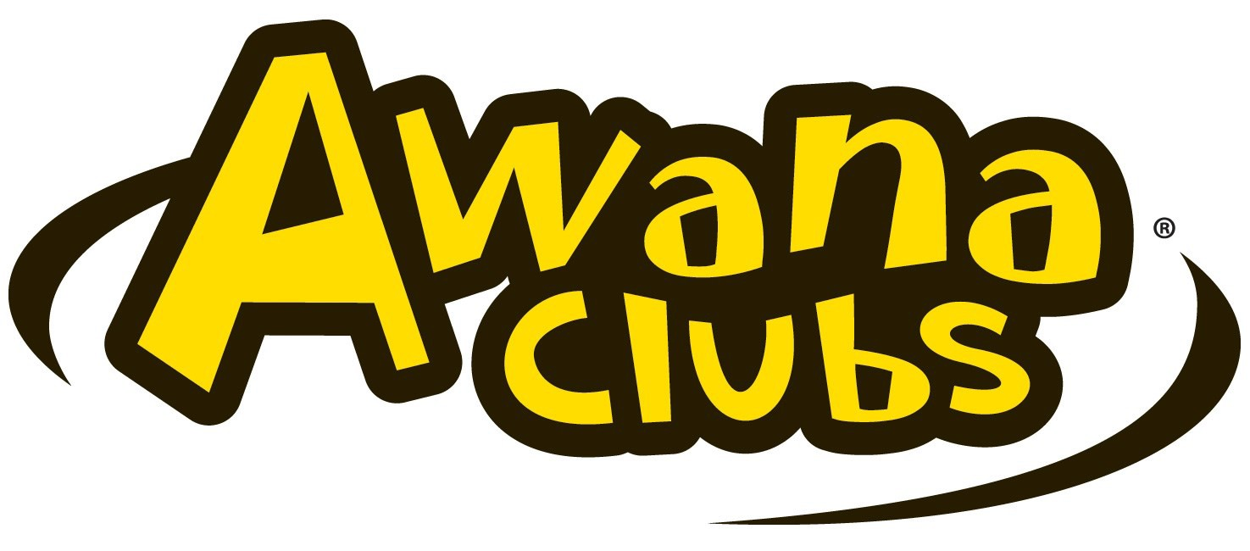
www.eva-bg-games-n-camp.org
Sparks Camp-A-Rama is a special day for 2nd grade Sparkies who have completed 3 years of work in their Sparks handbooks & have earned their Sparky Plaque. The recitation of at least 150 Bible verses is a great
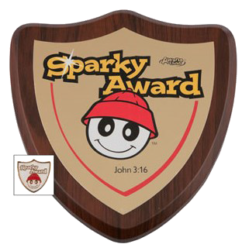
accomplishment for 2nd graders and this day is designed to reward them for this achievement. It is a day of celebration &
graduation from Sparks into T&T. This opportunity only comes once for these students. Join us in this fun-filled day for Sparkies & parents alike!

Games, food, singing, prizes, T-shirts, & goody bags full of gifts await you & your children!

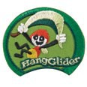
- One adult must be present for every 1 to 5 clubbers.
- Adults must accompany their Sparkies the entire day.
- The $30.00 non-refundable registration fee for each Sparky and each adult attending camp must accompany the online registration.
- Registration Form can be found on the www.eva-bq-games-n-camp.org website.
- A Parental Release Form must be brought for each Clubber. (Download this form at www.eva-bq-games-n-camp.org website.)
- Registration deadline is June 1, 2024.
.
- T-shirt, snack, lunch and camp souvenir goodie bag are included in the registration fee for both Sparky & Adult.

Be sure to wear your biggest & best smiles!!!
Who:

2nd grade Sparky Plaque Award Achievers in current club year.
Cost:

$30 per person
What to wear:

Clubbers should wear play clothes, and be dressed for outdoor and inside activities.

Camp-a-Rama will be held rain or shine.

(Pray for shine!)
?’s:

Visit the Awana Eastern Virginia web site:

www.eva-bq-games-n-camp.org

or contact Thom Carbaugh at (757) 875-5525 or cmdrthom@verizon.net

